ISAD 251 Coursework – Tea Room Application

**Application Design Document**

Put contents page here

Links

GitHub repository: <https://github.com/Squidgeypea/isad251_cw>

Project board: <https://github.com/Squidgeypea/isad251_cw/projects>

Introduction

This application is based on the theme of a tea room situated on board a fictional steam train, The Puffing Express, in the style of a train’s restaurant car. The application could be presented within the ‘tea car’ on a self-service device, integrated into the structure of the room, like the self-service devices currently found in some popular fast food outlets, or it could be accessed using a personal mobile device.

A GitHub project board was used to organise tasks and keep track of work.

Storyboard

The storyboard was edited to act on advice and ideas presented at the peer review. The changes are detailed on page of this document. The storyboard was created using the software application, Microsoft Paint.

The final storyboard is displayed here.

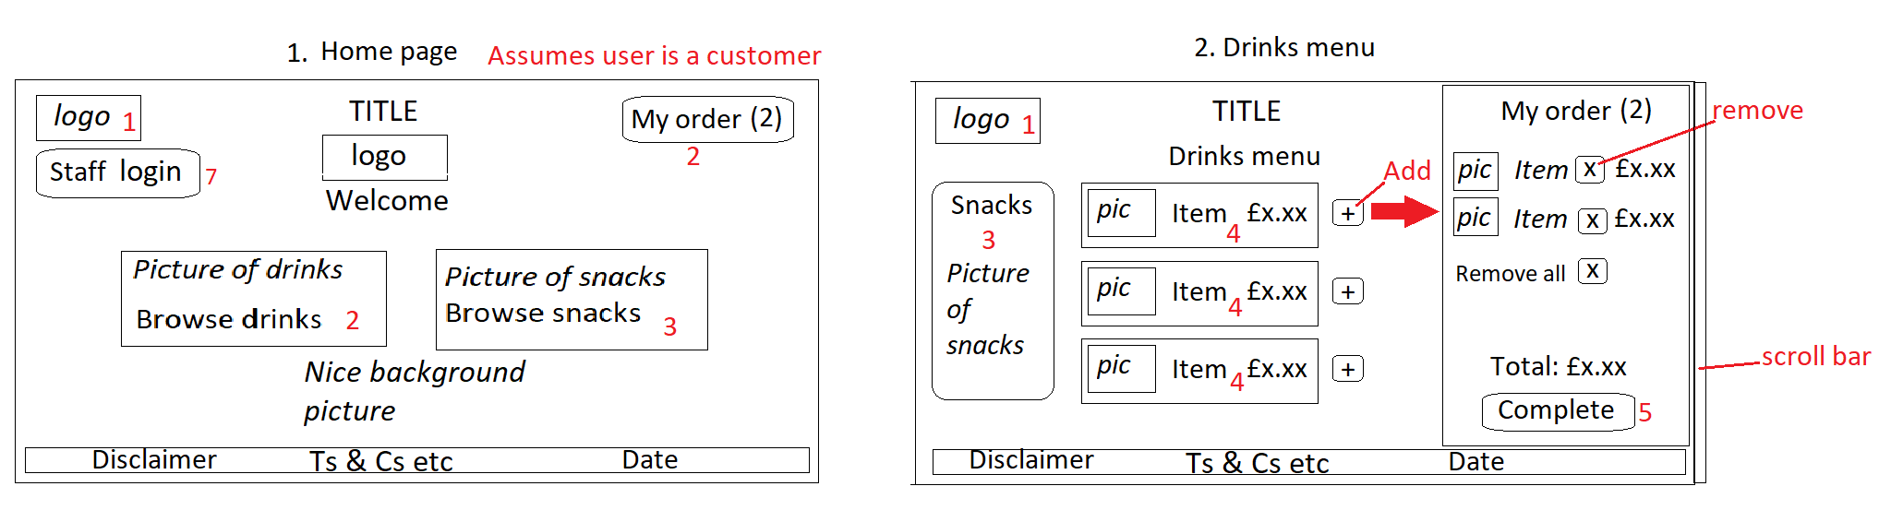

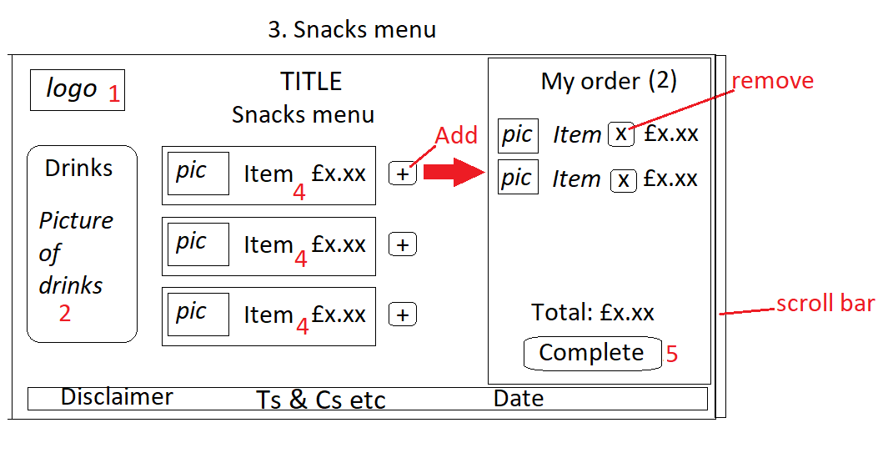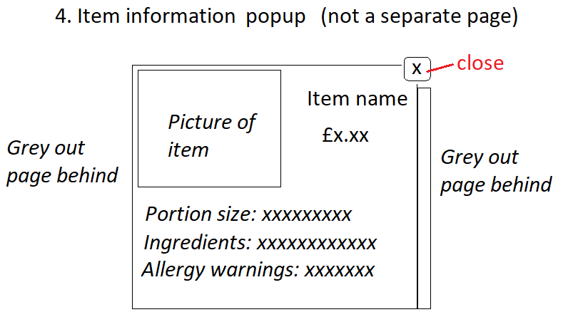

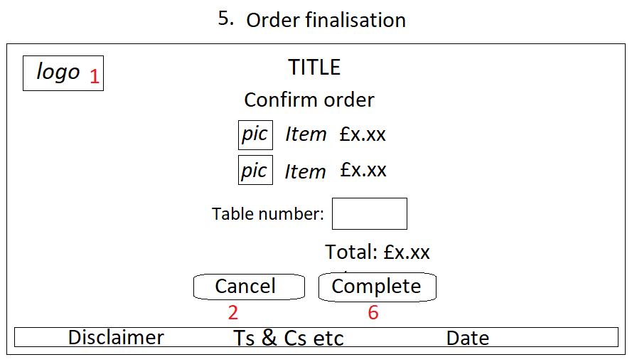 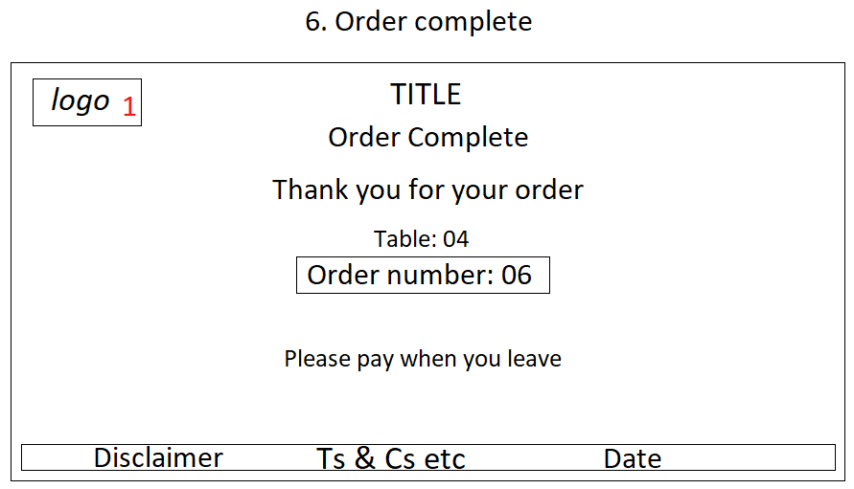

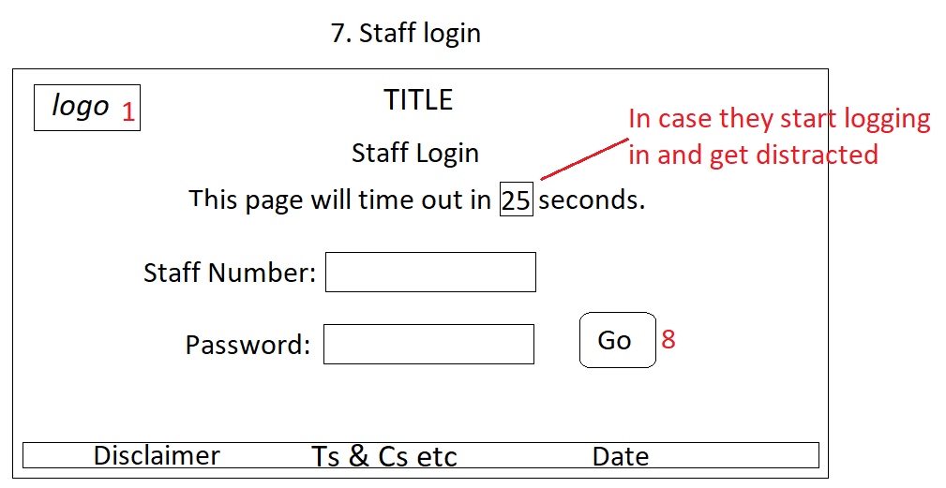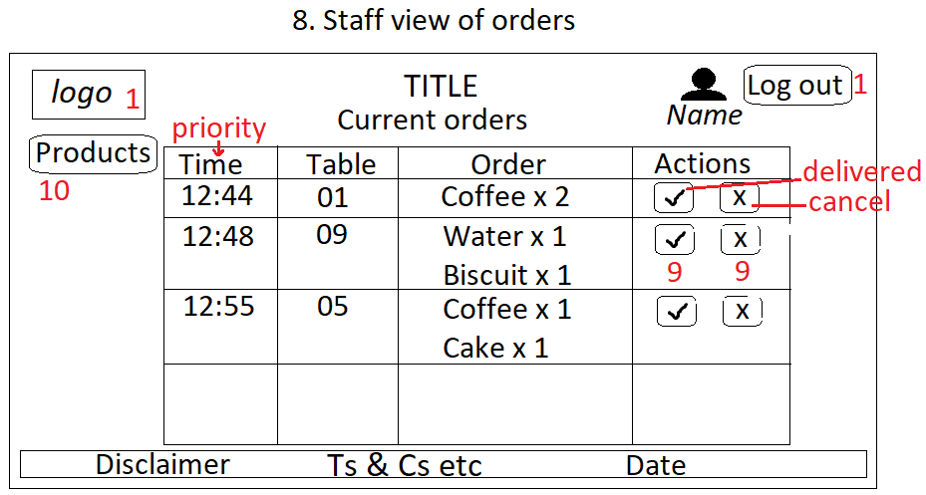

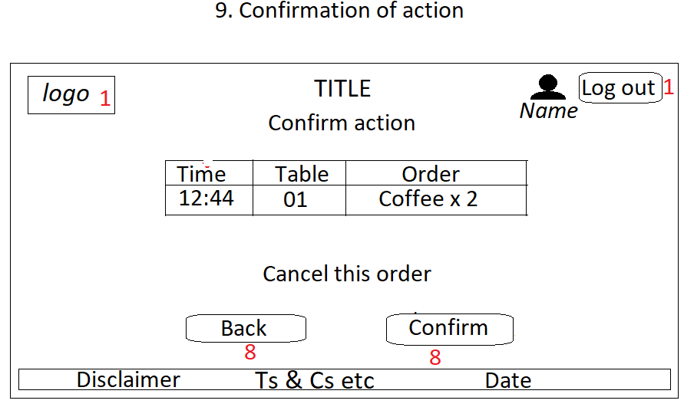 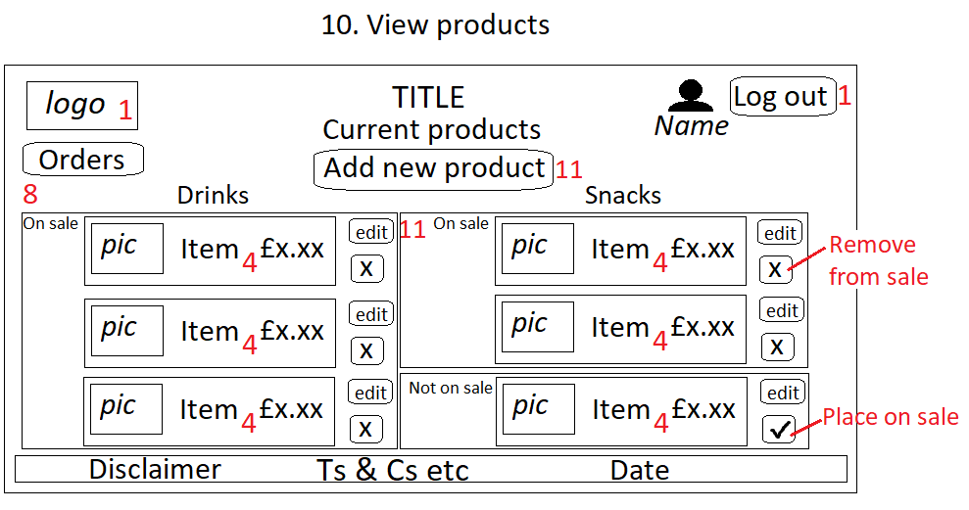

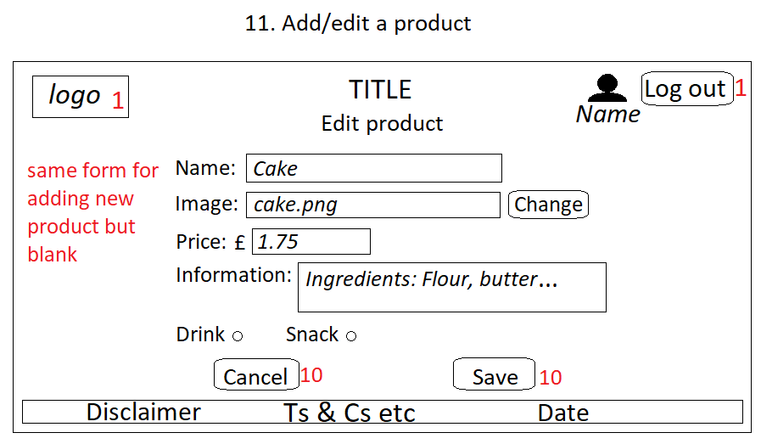

Entity relationship diagram

The entity relationship diagram was created using the web site, Draw.io.

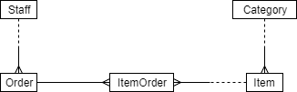

Normalisation

|  |  |  |  |
| --- | --- | --- | --- |
| UNF  OrderNum  TableNum  Completed  TotalPrice  OrderTime  StaffNum  StaffName  (ItemNum  ItemName  Quantity  OnSale  ItemPrice  ItemInfo  ItemPicFile  CatName  CatInfo  CatPicFile) | 1NF  OrderNum  TableNum  Completed  TotalPrice  OrderTime  StaffNum  StaffName  OrderNum  ItemNum  ItemName  Quantity  OnSale  ItemPrice  ItemInfo  ItemPicFile  CatName  CatInfo  CatPicFile | 2NF  OrderNum  TableNum  Completed  TotalPrice  OrderTime  StaffNum  StaffName  OrderNum  ItemNum  Quantity  ItemNum  ItemName  OnSale  ItemPrice  ItemInfo  ItemPicFile  CatName  CatInfo  CatPicFile | 3NF  **Orders**  OrderNum  TableNum  Completed  TotalPrice  OrderTime  *StaffNum  **Staff**  StaffNum  StaffName  **ItemOrder**  OrderNum  ItemNum  Quantity  **Item**  ItemNum  ItemName  ItemInfo  ItemPicFile  OnSale  ItemPrice  *CatName  **Category**  CatName  CatInfo  CatPicFile |

Database creation choices

|  |  |  |
| --- | --- | --- |
| **Attribute** | **Data type** | **Nullable** |
| OrderNum | INT | No |
| TableNum | TINYINT | No |
| Completed | BIT | No |
| TotalPrice | SMALLMONEY | No |
| OrderTime | DATETIME | No |
| StaffNum | SMALLINT | No |
| StaffName | VARCHAR(50) | No |
| Quantity | TINYINT | No |
| ItemNum | SMALLINT | No |
| ItemName | VARCHAR(50) | No |
| ItemInfo | TEXT | Yes |
| ItemPicFile | VARCHAR | Yes |
| OnSale | BIT | No |
| ItemPrice | SMALLMONEY | No |
| CatName | VARCHAR(50) | No |
| CatInfo | TEXT | Yes |
| CatPicFile | VARCHAR | Yes |

Unified Modelling Language diagrams

Settings and Images

The background image for the web site is owned by the developer.

Testing

Feedback

**Peer review of storyboard**

Is it OK to include their names? yes

Peer reviews of the storyboard were carried out on 15/10/2019.

|  |  |  |  |
| --- | --- | --- | --- |
| **Reviewer name** | Avy Gurung | Max Barker | Josh Franklin |
| **Errors identified** | Add/edit item part needs a category. | Basket may be incompatible with mobile devices. | Database will not be correctly populated with new item without category. |
| **Unclear parts** | None. | None. | None. |
| **Inspiration gained** | Include date in orders. | None. | Include category in add new item part. |
| **Constructive advice** | Include category in add/edit. | Make basket a slide-out or drop-down for mobile devices. | Have ‘on sale’ Boolean rather than just deleting an item.  Include functionality for forgotten passwords and to add new staff members. |

The following changes were made to the initial storyboard, to act on feedback received during the peer review.

**Screens 2 & 3 – Menus.**

It was suggested that the ‘My order’ section should be changed to a drop-down or slide-out for mobile use. This advice was followed.

**Screen 11 – Add/edit a product.**

It was pointed out that it was necessary to include the product category in the form to add or edit a product. This is because products will be shown to customers based on their category, which must not be null in the database.

Original design:

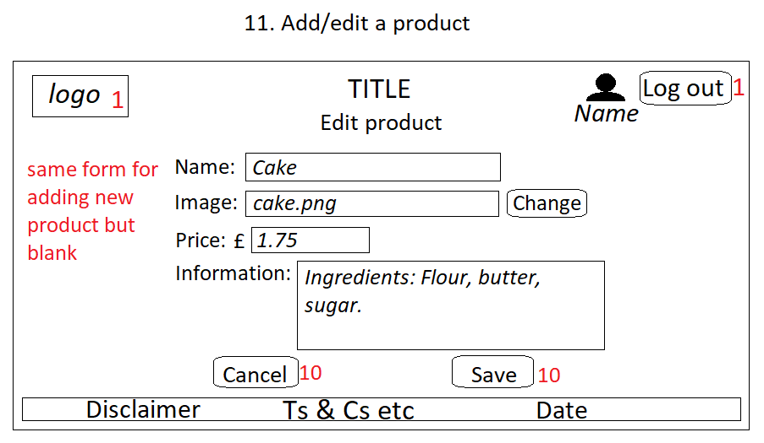

Final design:

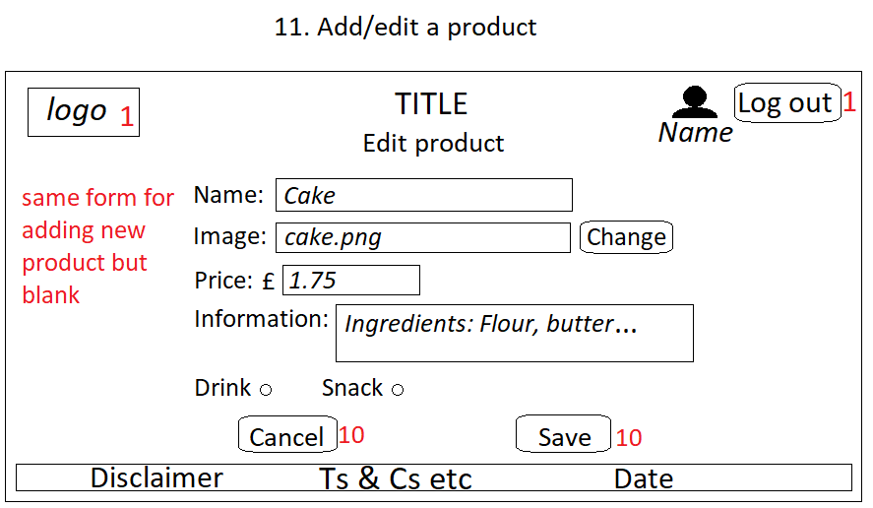

**Screen 12 – Remove a product.**

A peer commented that it would be preferable to remove a product from sale than to remove it from view altogether. This way, a staff member could easily decide to sell the product again in future without having to recreate the product. Since it would be easy to put the removed product back on sale, it was decided that screen 12 would no longer be necessary, and it was removed from the storyboard. Screen 10 was adapted to show the change.

Original design:

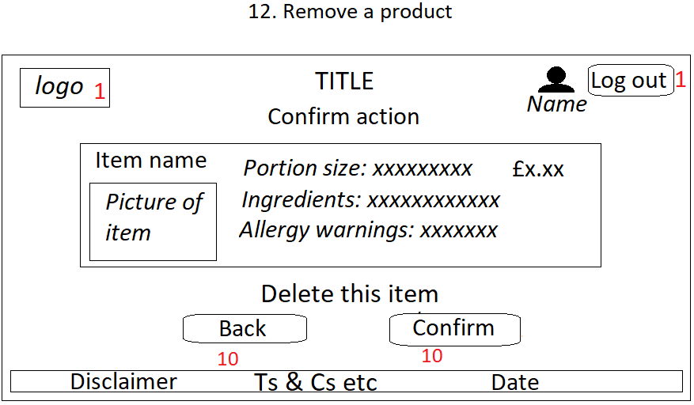

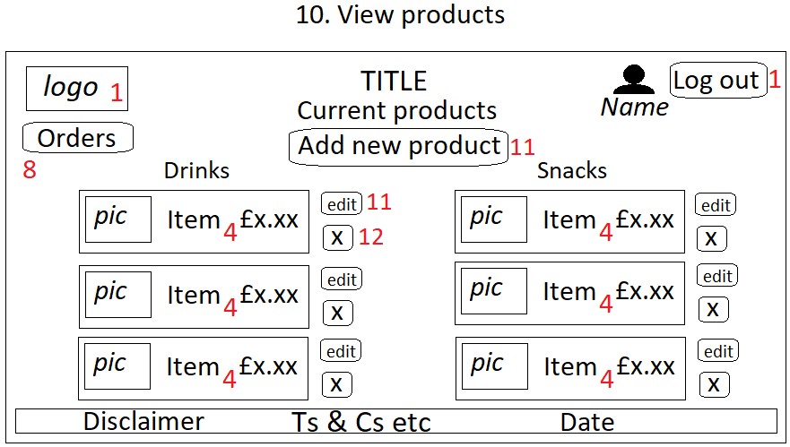

Final design:

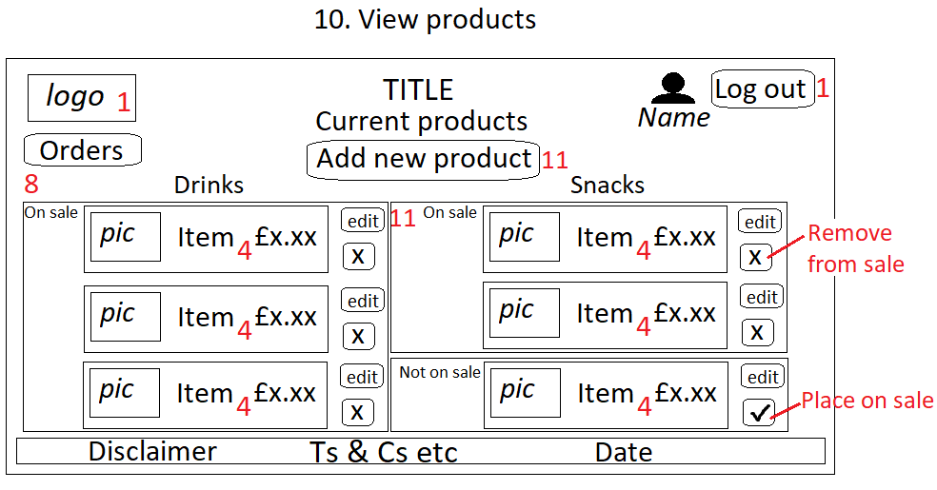

Analysis

Listed below are further improvements which could have been made, in addition to the suggestions from the reviews.

* Include the option to add a new category besides drinks and snacks.
* Make the application more compatible for mobile devices.
* Include a ‘forgotten password’ section.
* Provide the option to add a new staff member.

References?

Appendices?